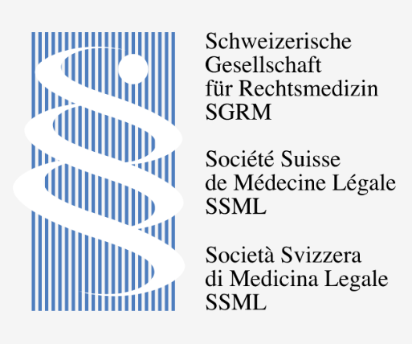 |  | SGRM 2023 Sommertagung Abstract Submission Form  Submission Deadline: 30.04. 2023
Type abstract within boxed areas, single-spaced, 10-point size, Times New Roman font.

Title

Author(s)
Name(s)
 | Use an asterisk (*) to identify the presenting author;
Author(s)
Affiliation(s)
Abstract | Introduction:  Methods:  Results and Discussion:  Conclusion:

Keywords (3)

